**What Founders Can Learn from Outbound Sales Teams**

The operational tactics that fuel repeatable sales processes have many applications for founders.



Selling the dream is a key part of a founder’s job, whether that means convincing investors to invest, prospects to buy, or candidates to join the company. Existing relationships can be a big advantage, but when you’re just starting up, outbound prospecting is crucial in expanding your network and building new relationships.

The most common approach to prospecting is intuitive: reach out, see what happens, and repeat. You soon learn it’s a numbers game: speak to enough people and you’ll occasionally strike it lucky and close a deal — whether with a new investor, recruit, or customer.

But how can you increase those odds of striking it lucky?

**Learning from sales teams**

For sales teams, prospecting and closing are full-time activities. Modern, at-scale teams have outgrown the intuitive approach and engineered processes that are more likely to turn leads into sales.

Of course, not all sales leads are created equal and for our purposes here, we can put them in one of three categories:

* Inbound leads — driven by ‘marketing’ activity (ads, content, events, etc.)
* Outbound leads — driven by sales (cold emails, phone calls, etc.)
* Referred leads — driven by customers (existing customers, prospects, partners, etc.)

Inbound and referred leads have higher conversion rates but tend to be less predictable than outbound leads. On the other hand, if you’re disciplined about reaching out to potential customers who are theoretically a good fit on paper you can begin to predict sales based on conversion rates. Effective outbound sales pipelines can achieve conversion rates of 20–40%.

Many of the concepts used by prospecting teams have applications beyond sales, for example, in recruiting, marketing, and fundraising. Here are six of these concepts every founder should understand:

* Structuring pipelines
* Creating leads lists
* Framing conversations
* Building message sequences
* Managing your time
* Generating referrals

**1. Structuring pipelines**

In 2011, Marylou Tyler wrote a book called [Predictable Revenue](https://www.amazon.co.uk/Predictable-Revenue-Business-Practices-Salesforce-com/dp/0984380213), known by many as ‘The Sales Bible of Silicon Valley’. Marylou describes four stages in a typical sales development pipeline:

* **Cold** — people who haven’t yet engaged with your business and you can reach out to
* **Working** — people you’re actively talking with
* **Qualify**— people who are actively deciding whether there’s a fit
* **Sales qualified leads (SQL)** — people who are a fit and want to work with you

She also describes two further buckets for those who aren’t a fit:

* **Long-term follow-up**— people who aren’t a fit yet, but may be in the future
* **Do not contact**— people who aren’t a fit

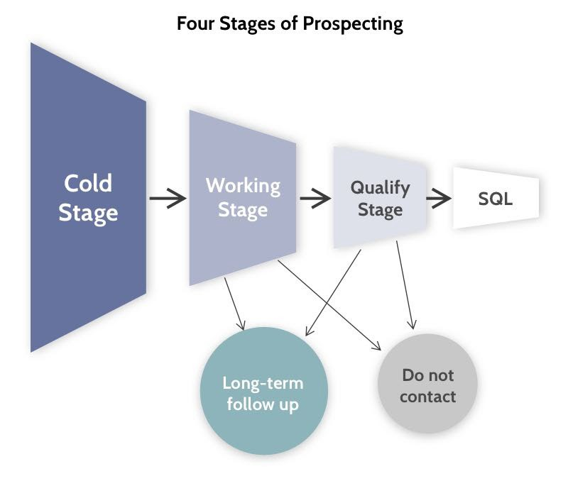

Key stages of a sales development pipeline, from [Predictable Revenue](https://www.amazon.co.uk/Predictable-Revenue-Business-Practices-Salesforce-com/dp/0984380213).

A pipeline doesn’t just organise the status of leads, it also prescribes the next step of the process — typically, a response or a follow-up. Following up is often neglected, either for fear of ‘being too pushy’ or due to disorganised, inefficient processes. However, a well-written follow-up is often makes the difference between success and failure.

CRMs such as Pipedrive can also help, by flagging leads that don’t have a predetermined next step, so they don’t fall through the cracks.

**2. Creating leads lists**

When you have a pipeline, you need to fill it with leads, whether they’re investors, candidates, or companies. The first step is to identify your ideal customer profile (ICP) — a description of the ideal characteristics associated with the people or businesses you want to sell to. While you might have to start by making some smart assumptions, you’ll quickly learn which profiles actually respond, convert, and succeed, enabling you to update your ICP accordingly.

The more clearly you can articulate your ideal customer, the more likely it is that you’ll find them.

But finding them requires research. There are lots of places you might look, depending on what you’re selling. For example:

* **Customers:** LinkedIn, AngelList, directories, existing databases, your network
* **Recruits:** LinkedIn, your network, your existing employees
* **Investors**: Investor databases, founders in your network

Aside from decision-makers, you might also reach out to indirect and direct influencers, who can help you gather company-specific information or internal referrals and practice your narrative. Here’s an example of an influencer mapping for the General Partner of a VC fund.

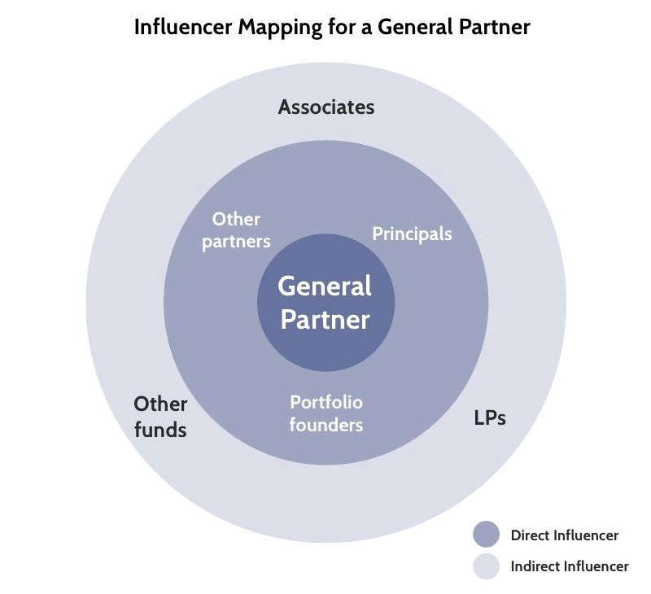

It’s unrealistic to think that all cold leads will convert straight away — particularly since timing is such an important component of every deal. Indeed, if you have this mindset, you’re likely to be seriously demotivated by the first ‘no’. Instead, consider the following [rules of thumb from Tyler’s research](http://maryloutyler.com/portfolio/episode-141-talking-to-the-right-person-tukan-das/):

* 3% of prospects are ready to buy immediately
* 7% are close to being ready to buy
* 60% don’t yet know whether they want to buy — they need nurturing
* 30% aren’t interested and won’t talk with you

The largest group of potentially-willing leads isn’t yet ready to buy, so in sales, pleasant and patient persistence wins.

The second-largest group knows they don’t want you (or will be deciding between you and a competitor), making them unlikely wins, so you need to continuously replenish your lists with high-quality leads.

**3. Framing conversations**

If you manage to get a moment of your prospects’ time, you need to give some thought to the kind of conversation or content that’s got the best chance of success.

Most of the highest-performing sales teams collect data about which conversations convert. While you may not have the volume to run statistically valid tests, generating an extensive list of potential conversations can increase your chances of finding one that works (just like coming up with a good article headline . . .).

Here’s a simple way to generate just such a list. Firstly, write down the key topics your ICP cares about — this might include the specifics of their problem, their perceptions of your product, or even broader issues with the industry. As non-sales examples, potential employees might care a lot about company culture, perks, or a key industry trend.

Secondly, you can ‘frame’ the conversation in terms of its strategic, financial, or personal impact. Using our fictitious conversation with an employee about company culture, you could frame it as:

* The importance of culture in building a successful business (strategic)
* The hidden costs of working in a toxic culture (financial)
* The mental impact of working in a good culture (personal)

Framing the conversation like this triples the number of topics you could discuss, but by defining the *emotion* you want to tap into, you can help generate even more topics. For example:

* The importance of building a culture your team can be **proud** of (strategic)
* The **depressing** costs of working in a toxic culture (financial)
* The **motivation** that comes from a good culture (personal)

Once you have a long list of potential conversations, you can prioritise them based on estimated impact. If you have enough volume and you’re willing to standardise your approach, you can measure the effectiveness of different conversations on response or conversion rate.

That said, when you’re a team of one with a relatively small number of prospects, you may opt to personalise every email.

**4. Building message sequences**

As I mentioned earlier, every follow-up increases the chance of getting a response. Tyler’s research suggests that eight reach-outs can increase the response rate from 3% to 28% — that’s nearly 10X the results.

Therefore, you can think of cold reach-outs as a measurable sequence of emails, not just one — each one setting up a different conversation (from above). Sequences can be as complicated or as simple as you like. For example:

* Day 1, 3, 7, 14, 28 and once monthly
* Day 1, 2, 3, 7, 7, 11, 20 and once quarterly
* Day 1, 1, 7, 7, 10, 10, and once every four months

Writing good emails takes practice, and I can’t predict which emails will work for you. Common wisdom advises us to include emotional triggers in your subject; focus on a specific problem, outcome and call to action; and be as concise as possible (unless you really are Ernest Hemmingway… in which case write on!)

The call to action may be as simple as replying to the email, or setting up a quick call or meeting to continue the conversation.

Just as cold emails follow a sequence, so do meetings. In recruiting, the meetings depend on your [structured interview process](https://medium.dave-bailey.com/how-to-design-a-great-interview-process-ba1627e44abe); similarly, some investors have their own process for evaluating deals.

As for sales, Tyler suggests that a [three-meeting sequence](https://principus.si/2020/04/20/aaron-ross-marylou-tyler-predictable-revenue-sales-practices-from-salesforce/) is enough to close simple deals:

* **Step 1: First Contact** — to quickly figure out if it’s a waste of time (15 mins)
* **Step 2: Discovery Call**— to figure out if there’s a fit (1 hour)
* **Step 3: Group Working Session**— to build a common vision around working together (2 hours)

That’s 3 hours and 15 minutes to close a sale — assuming you’re successful. Yes, every form of selling takes a lot of time.

**5. Managing your time**

Given the large number of tasks involved in sales development, many salespeople use the Pomodoro technique to organise their day into 25-minute work sprints, with each followed by a five-minute break. Scheduling in tasks — like writing emails, researching leads, and taking calls — ensures that they will happen, and batching them can increase efficiency.

Here’s an example of what a sales rep’s [calendar might look like](https://calendly.com/blog/timeboxing-double-your-sales-reps-output-with-this-calendar-strategy/):

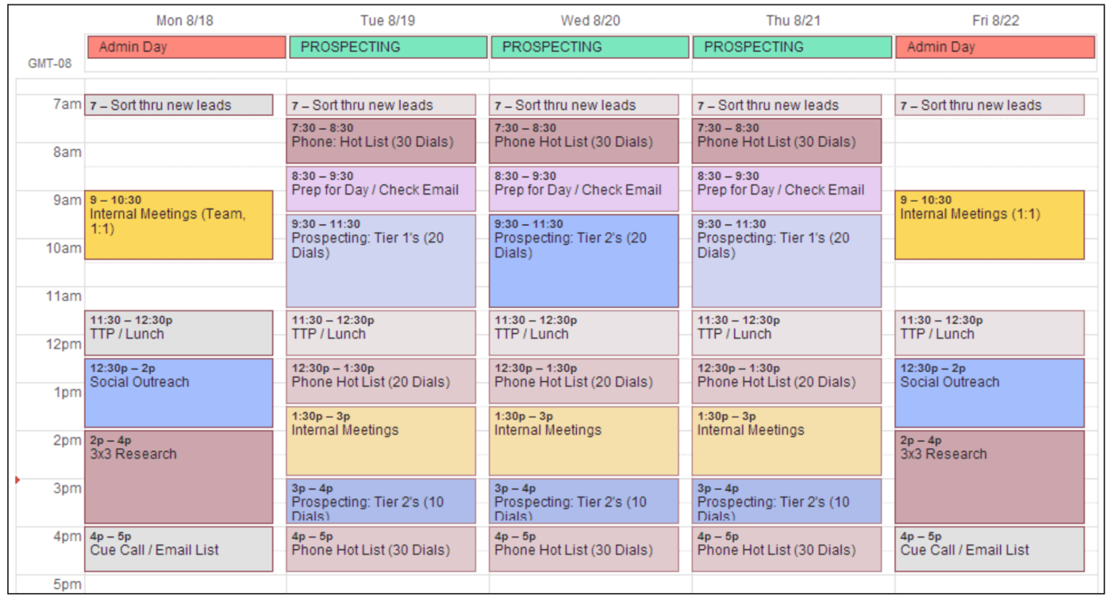

Planning your schedule forces you to quantify how much time is needed to manage the pipeline — and it’s often more than you think.

That’s one reason why fundraising can take a founder out of the business for several months, and why recruiting often takes longer than most founders expect.

**6. Generating Referrals**

This isn’t strictly prospecting, but it’s so frequently overlooked that I wanted to talk about it anyway. Conversion rates from referrals typically outperform every other channel, yet it’s the channel most companies spend the least amount of time on.

Think about all the investors, customers, and network connections that interacted with your business last week. How many opportunities did you take to ask for a warm referral? Exactly… and that’s a lot of missed opportunities.

Whether you’re looking for new customers, investors, or recruits, asking your existing network for referrals is a great starting point.

**Make it rain**

Understanding the approaches that sales teams take to build repeatable processes can help you close deals in areas beyond sales. If sales is an art, growth is a science — but it’s not rocket science. Stay organised, stay optimistic, and please, don’t forget to follow up!